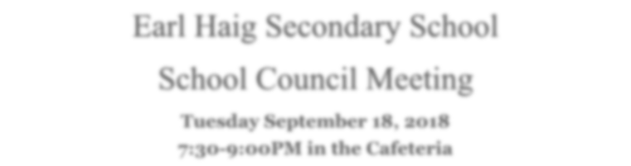
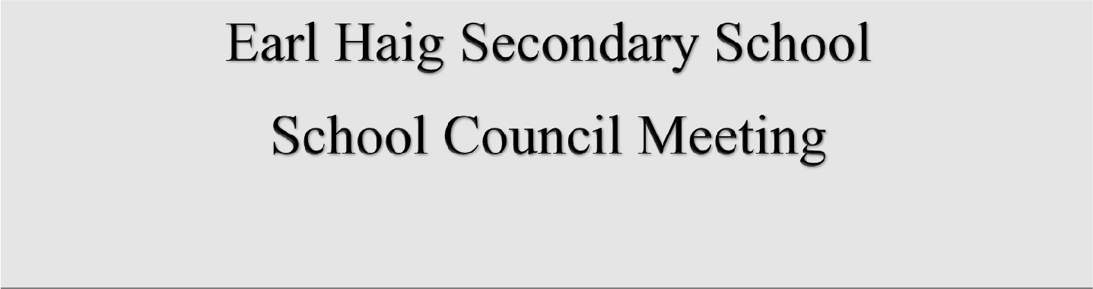

Tuesday, September 10th, 2019
7:30-9:00PM in the Cafeteria

The EHSS School Council is pleased to welcome you to our Annual General Meeting to kick off the 2019-2020 school year.
Agenda
- Welcome and Introductions
- School Council Annual Report - Susan & Chandra
- Principal’s Update & Introduction of Vice Principal’s – Ricky Goldenberg
- Student Activity Council Update –SAC President, Ivy Deng
- Time Management Tips
- Election of 2019-2020 School Council
- Adjournment

A l l P a r e n t s a n d G u a r d i a n s a r e W a r m l y I n v i t e d t o A t t e n d !

Annual General Meeting
Election of the 2019-2020 School Council Executive
If you wish to be nominated for the 2019-20 School Council Executive, the Nomination form is available on the Earl Haig website (http:// http://earlhaig.ca/council/index.php ), click on School Council Nomination Form. Submission deadline is 3:30 pm on Friday, September 6th → Delivery to the school main office.

